Title:

“When You Would Rather

Be Fishing”
John 21: 15-17ESV

Sermon Notes

April 19, 2020
Pastor Mark Hensley
¹⁵ When they had finished breakfast, Jesus said to Simon Peter, “Simon, son of John, do you love me more than these?” He said to him, “Yes, Lord; you know that I love you.” He said to him, “Feed my lambs.” ¹⁶ He said to him a second time, “Simon, son of John, do you love me?” He said to him, “Yes, Lord; you know that I love you.” He said to him, “Tend my sheep.” ¹⁷ He said to him the third time, “Simon, son of John, do you love me?” Peter was grieved because he said to him the third time, “Do you love me?” and he said to him, “Lord, you know everything; you know that I love you.” Jesus said to him, “Feed my sheep.

“When You Would Rather Be Fishing”
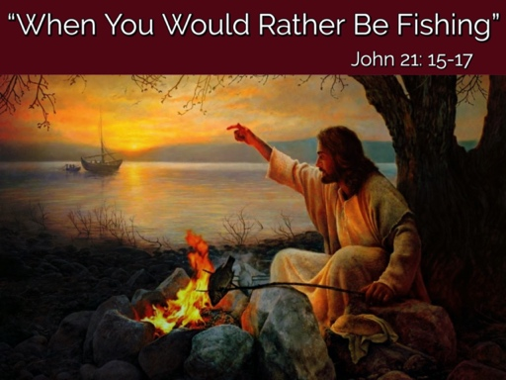

We Need to Listen to the Lord
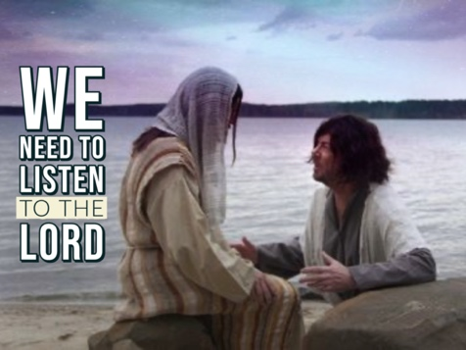Our relationship with the Lord determines achievement and purpose in every realm of our life!

We Need to Realize our Weakness
We must not rely on our own ingenuity or ability, dependence ultimately on the Lord is crucial!

NOTES: ________________________________________________________________________________________________________________________________________________________________________________________________________________________________________________________________________________________________________________________________________________________________________________________________________________________________________________________________________________________________________________________________________________________________________________________________________________________________________________________________________________________________________________________________________________________________________________________________________________________________________________________________

